Weather API Client – Technical Documentation
Objective of the Project
This project implements a professional-grade Python client to consume the WeatherAPI and retrieve current weather information for multiple cities in a robust, secure, and scalable way.
The application:
Reads the API key securely from environment variables
Queries real-time weather data
Normalizes the API response
Displays clean, human-readable results
Handles errors gracefully
High-Level Architecture
The code follows a layered architecture, even in a single file:
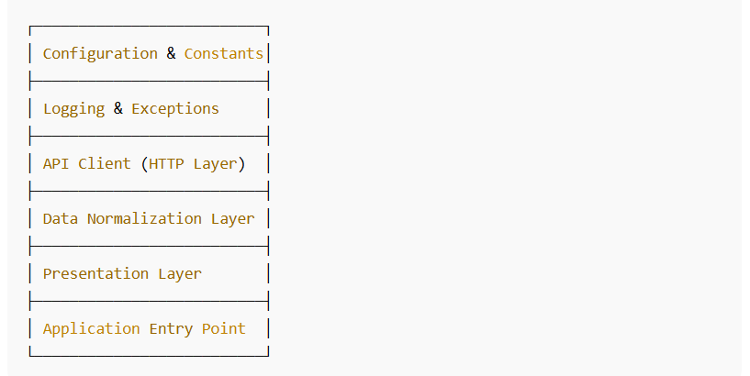
This structure ensures:
Separation of concerns
Testability
Maintainability
Easy future expansion

Dependencies and Environment Setup
External Libraries
Requests is used for HTTP communication with the WeatherAPI.
It provides timeout handling, status validation, and clean response parsing.
Standard Library Modules
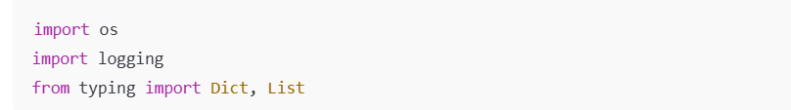
os: Reads environment variables securely.
logging: Professional logging (preferred over print).
typing: improves readability, static analysis, and IDE support.
Configuration Section
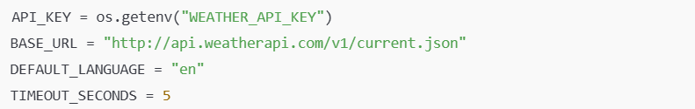
Purpose:
Centralizes all configuration values
Avoids magic numbers or hardcoded values
Makes the application environment-agnostic
Key points:
API_KEY is never hardcoded
Timeout prevents hanging requests
Language can be changed globally

Logging Configuration
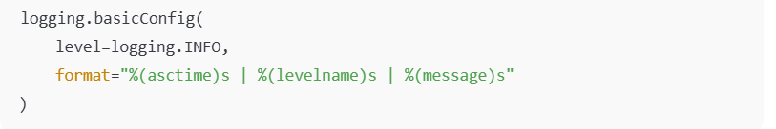
Why logging is used instead of print:
Supports log levels (INFO, ERROR, DEBUG)
Can be redirected to files, monitoring tools, or cloud platforms
Essential for production environments
Custom Exception Handling
